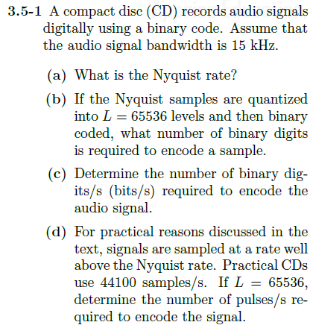

If maximum frequency to be sampled is 15kHz, then Nyquist rate is twice that at 30kHz

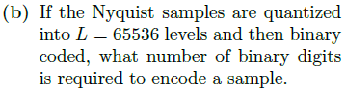

16 bits are required (2^16)

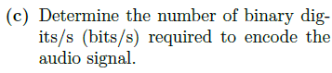

16 bits to record in one sample, 30 thousand samples per second

$$16 bits*30,000\frac{samples}{second}=480,000\frac{bits}{s}$$

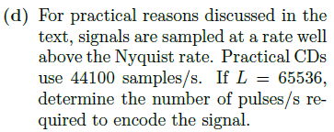

$$16 bits*44,100\frac{samples}{second}=705,600\frac{pulses}{s}$$